***Applied Cryptography***

By,

Abhishek Paleli George

10724389

1) Question 1: Asymmetric cryptography and Diffie-Hellman

a)

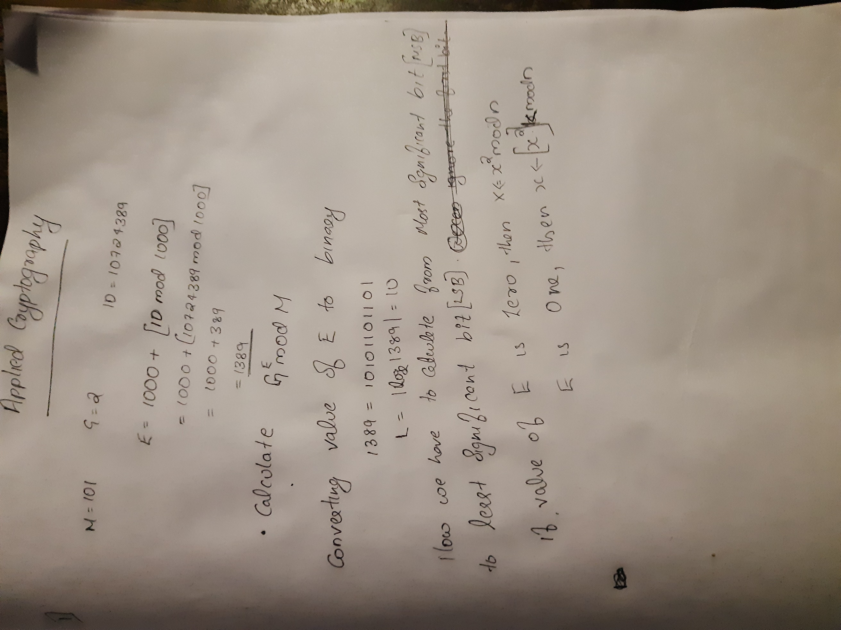

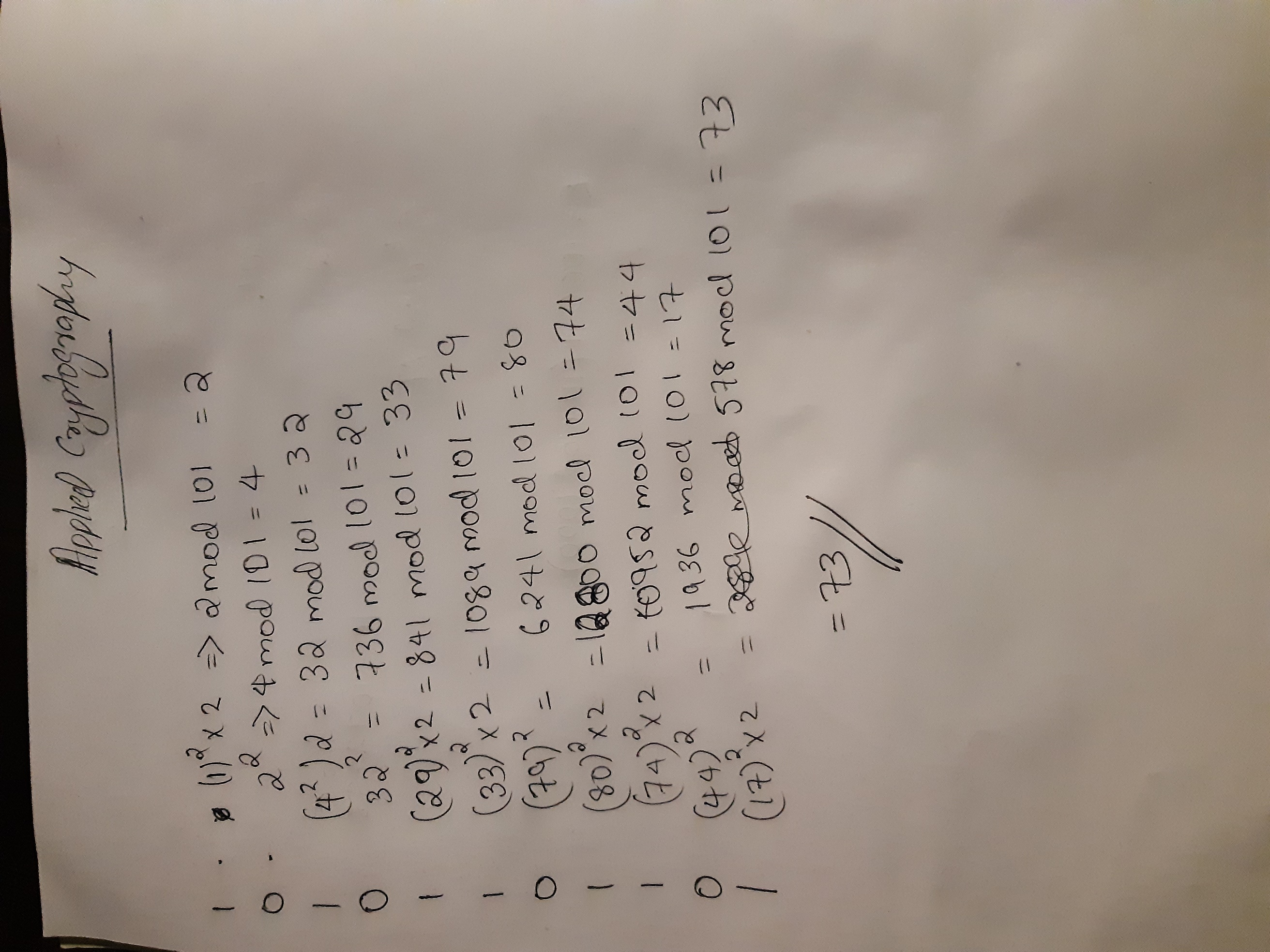

b) The first instance where we use square and multiply algorithm is to calculate public key. The second instance where we use square and multiply algo is in order for same key generation during key decryption.

c)The Two security defects of such a choice is :

* Due to the fact that this is an unauthenticated key exchange, man in the middle is possible.
* For this scenario we are considering our m as 101, which is a number that can be easily broken using brute force attack.
* The type on input in first instance is both Alice and bob using Secret key to compute A=g.modp and B=gb.modp
* The Second type of input usuing computer secret key with A and B values. S=Ba. Mod p

Bob uses S= Ab mod p

2) Question 2: Public-key encryption with ElGamal

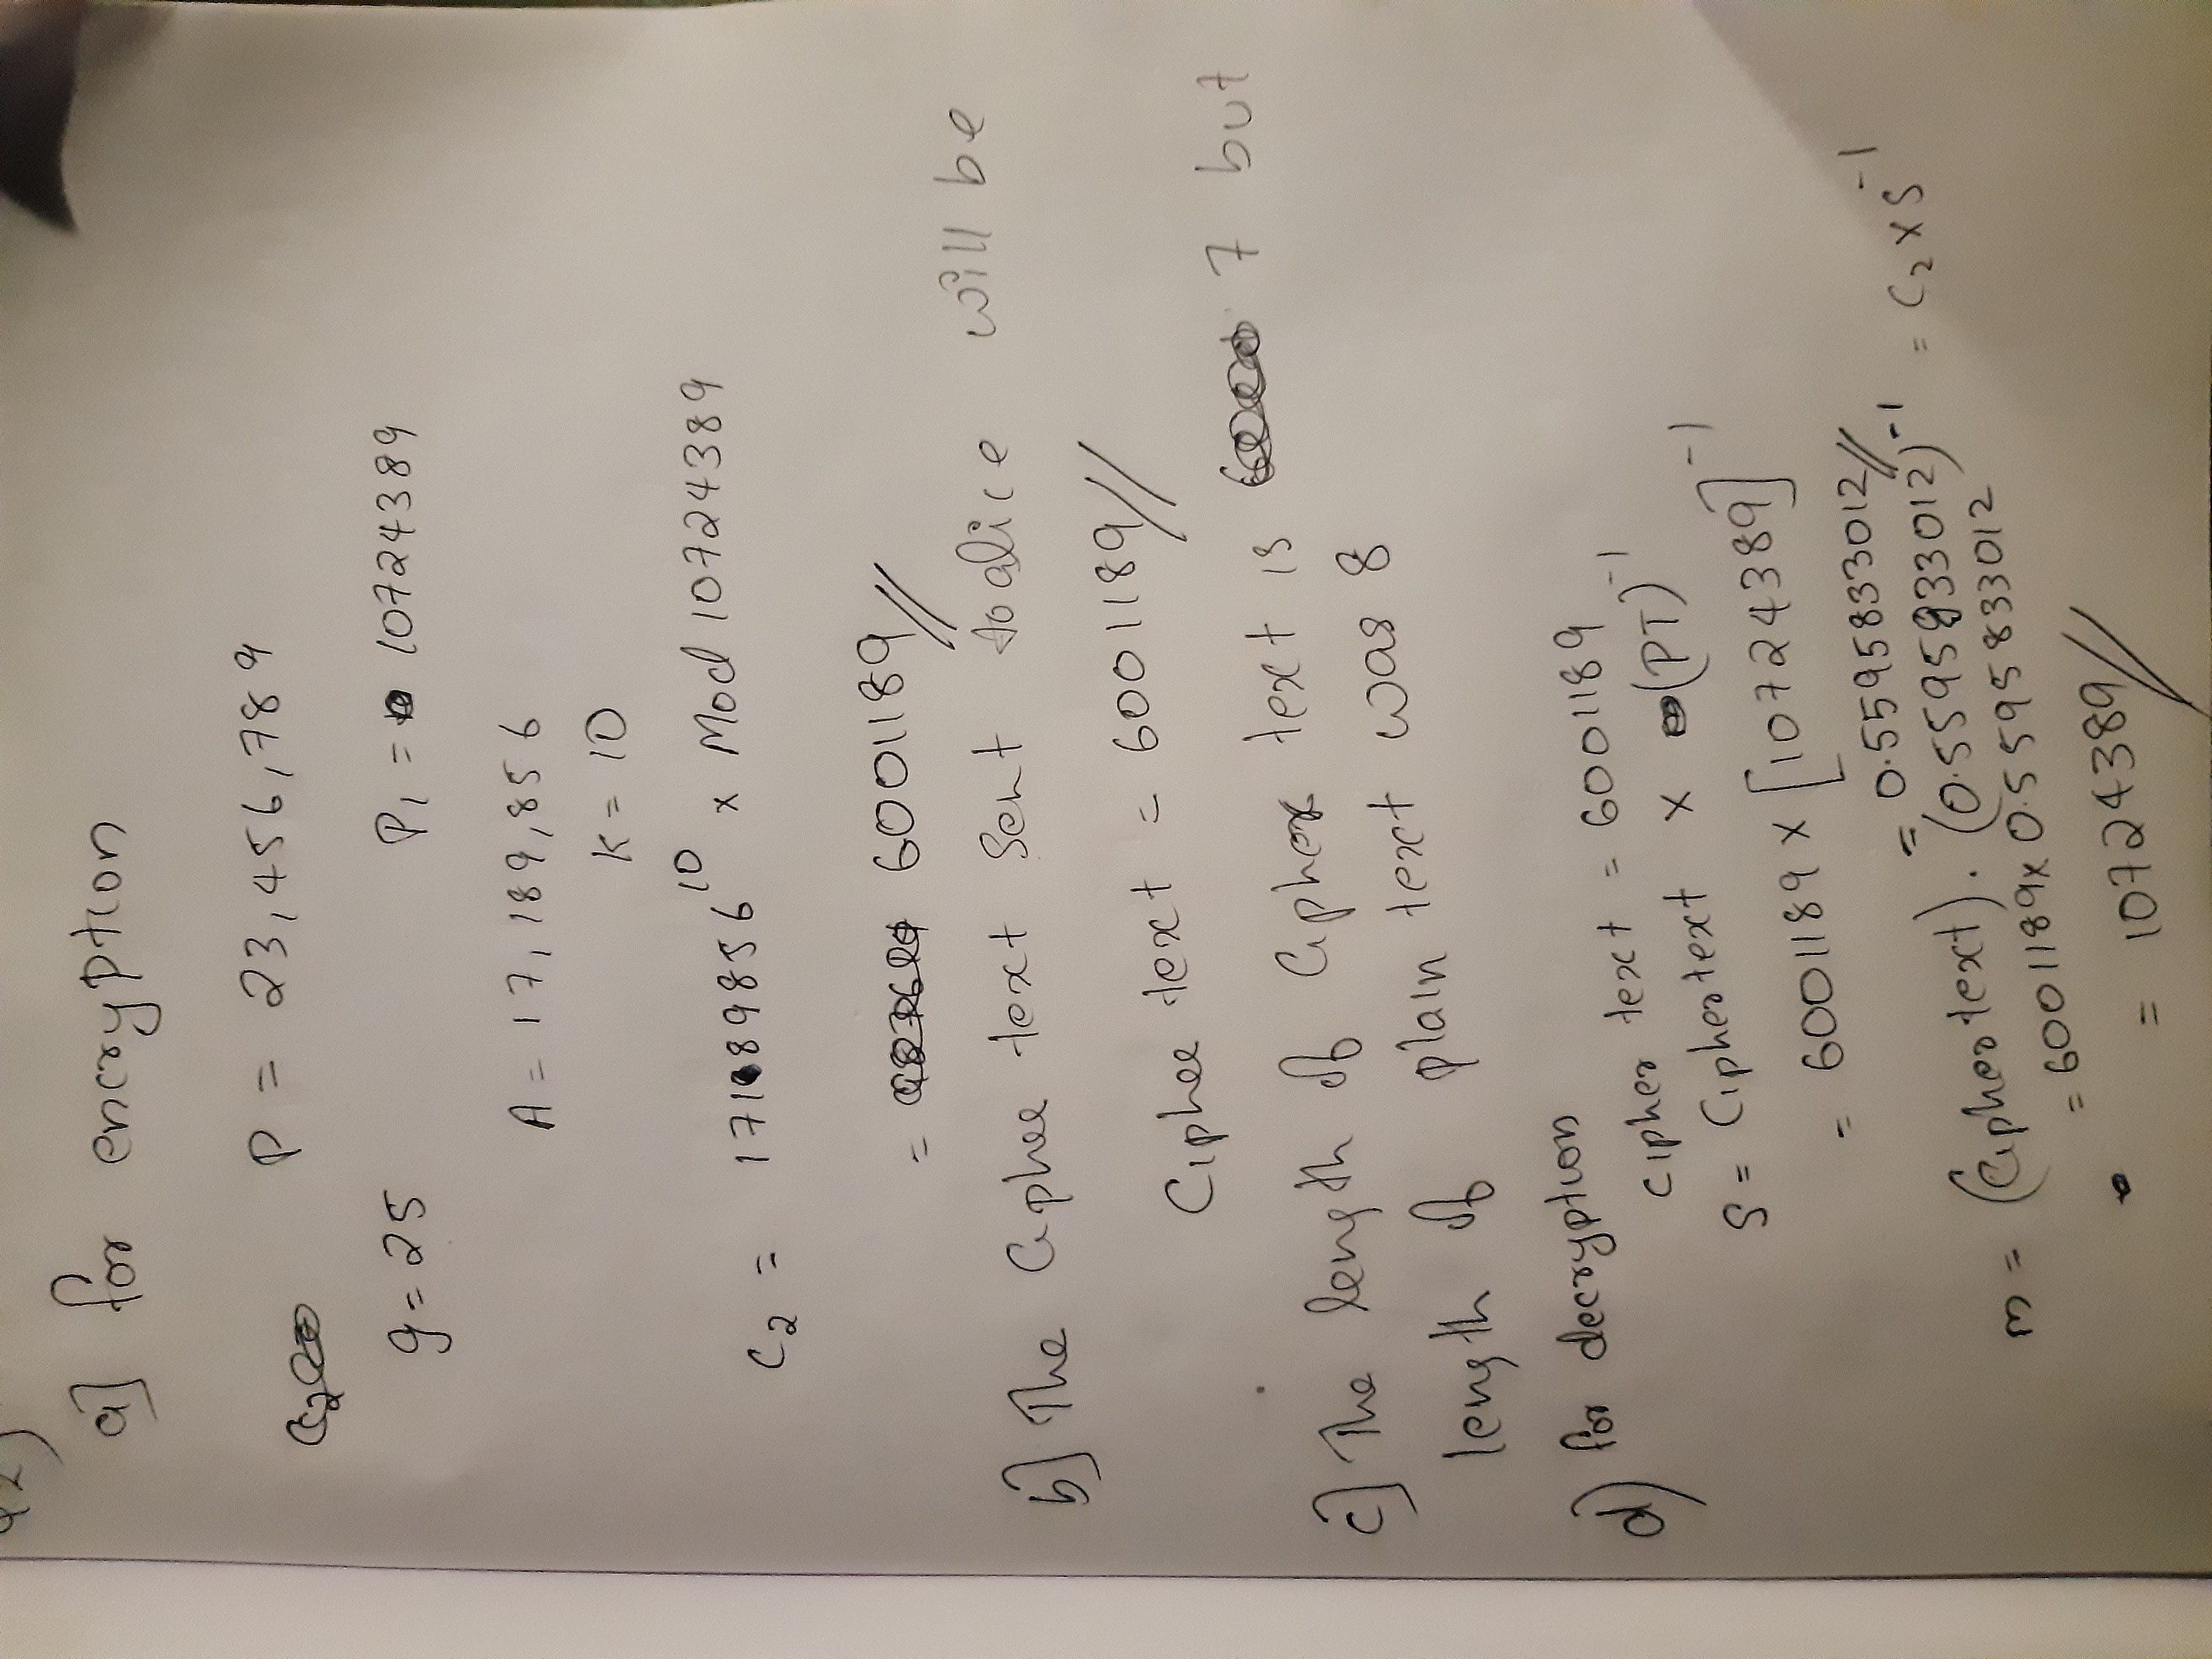

3) Question 3: Public-key encryption with ElGamal and RSA

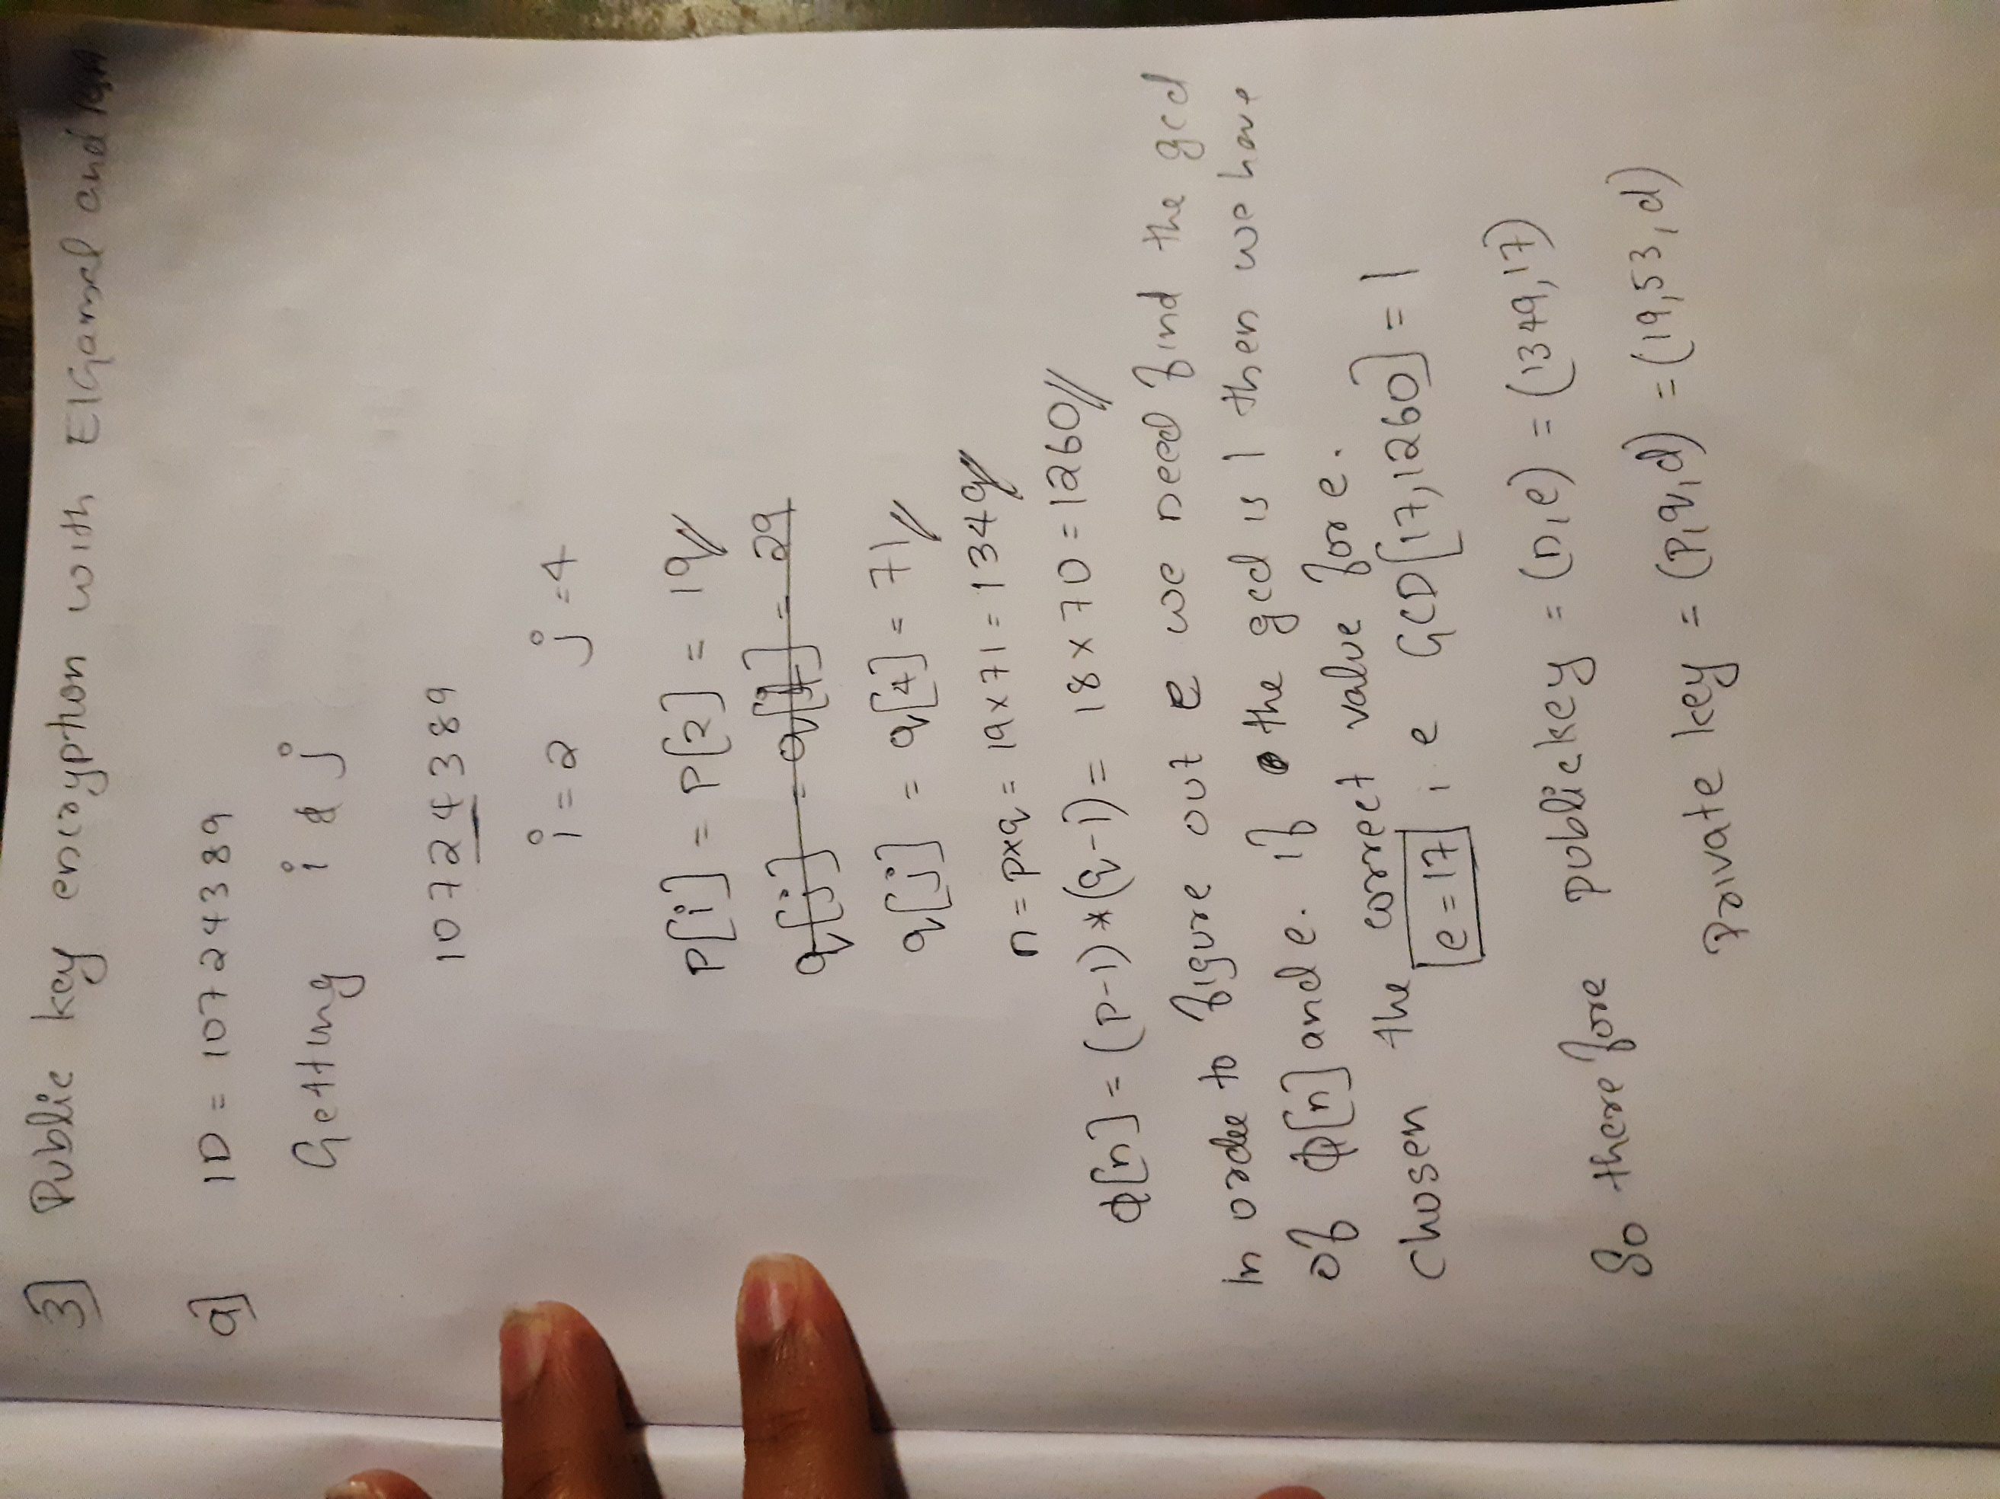

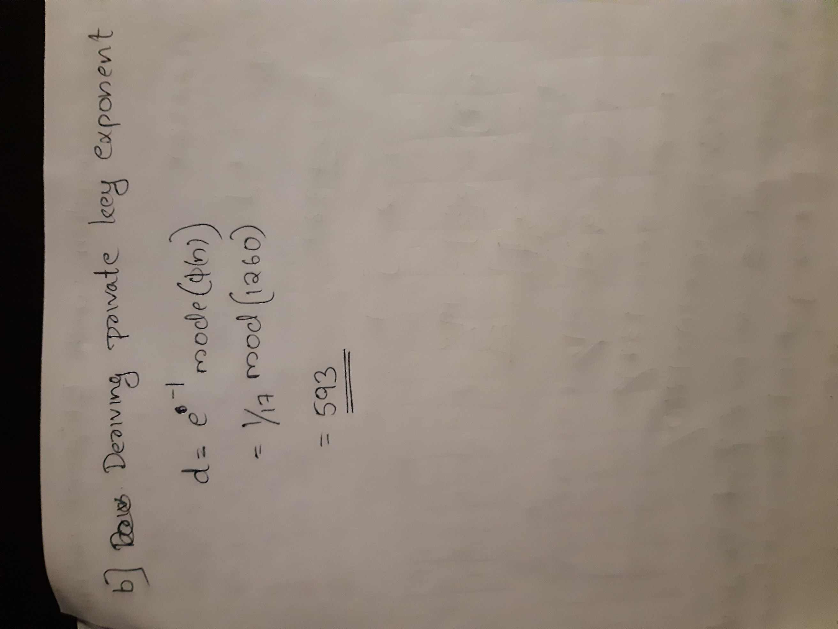

4) Digital Signatures

1. The plain text we are considering is

P2= Abhishek George Paleli

Signature is = D7 00 6B 00 D2 00 5B 00 0D 00 01 01 17 00 00 01 B0 00 BD 00 54 00 47 00 19 01 31 00 29 00 A3 00 1A 01 C7 00 BD 00 CA 00 0D 01 01 00 19 01 F8 00 AC 00 00 00 0E 00 B8 00 21 00 DC 00 14 01 20

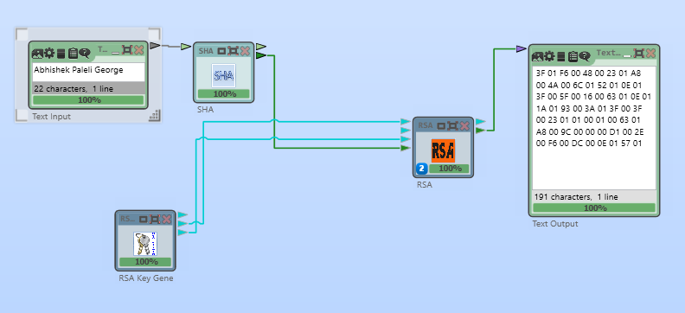

Steps Followed

* Use CrypTool , open a new project and drag and drop the following items, text input box, SHA,RSA, Rsa Key generator, Text Output Box.
* Now connect the items seen in the picture, Make sure you are setting SHA into 256 mode, and RSA as encryption mode.
* Give the values shown below as the values in RSA key Generator

Public modulus N= 365

Public exponent e=43

Private key d=45

* Make sure you are connecting to the correct ports in all the objects that we are using.
* Now fire the request and you will get the signature

1. In order to achieve successful verification of signature the patron who verifies it needs sender’s public key.
2. In order to verify RSA signature you need the help of cryptool again

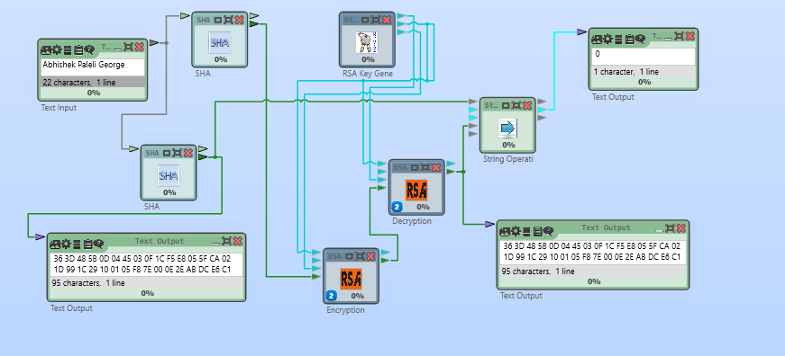

* Use CrypTool and open a new project and drag and drop the following items, text input box, SHA(256 mode), RSA (2), RSA Key generator, Text Output Box (3), string operation.
* In this method we sending RSA key generator’s public key and public exponent to RSA decryption module along with the digital signature from RSA encryption module.
* The output from decryption unit is compared with SHA encrypted message using a string operator.
* If the string operator returns 0 then we can prove that we have successfully verified the digital signature

5) Question 5: Elliptic curves

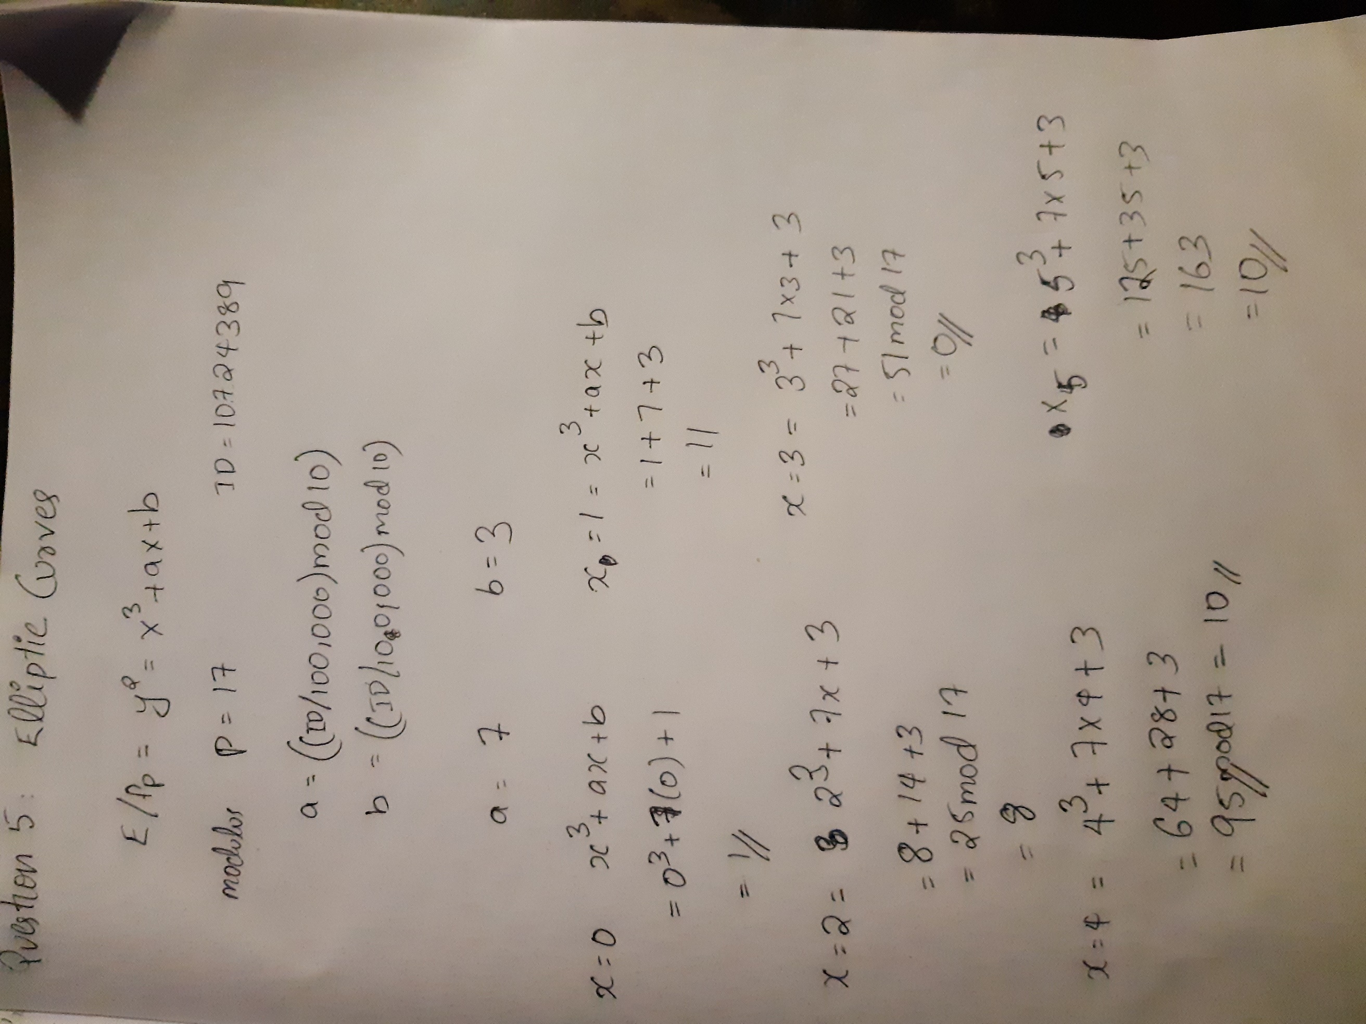

a)

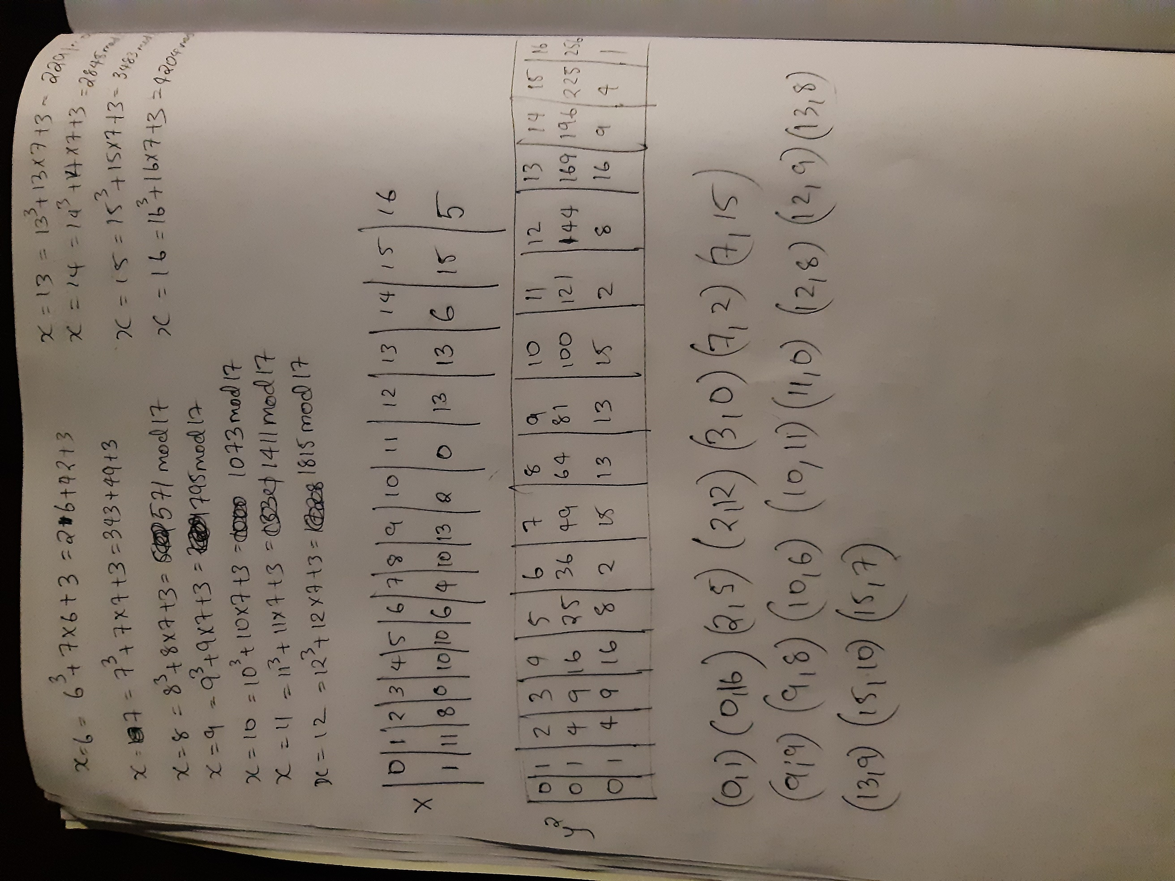

b)

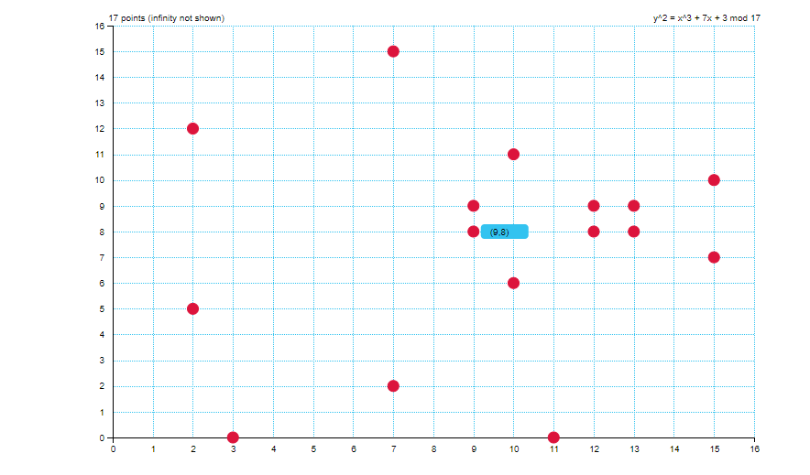

c)There are 20 points in graph plus one for infinity therefore order is 21

d) Yes, in our case all in x is sharing same value, this was expected due to the symmetry of the graph.

e) Yes, we can find we can find values for ex where there is no point for that value in graph, this is due the symmetry problem at that particular point.

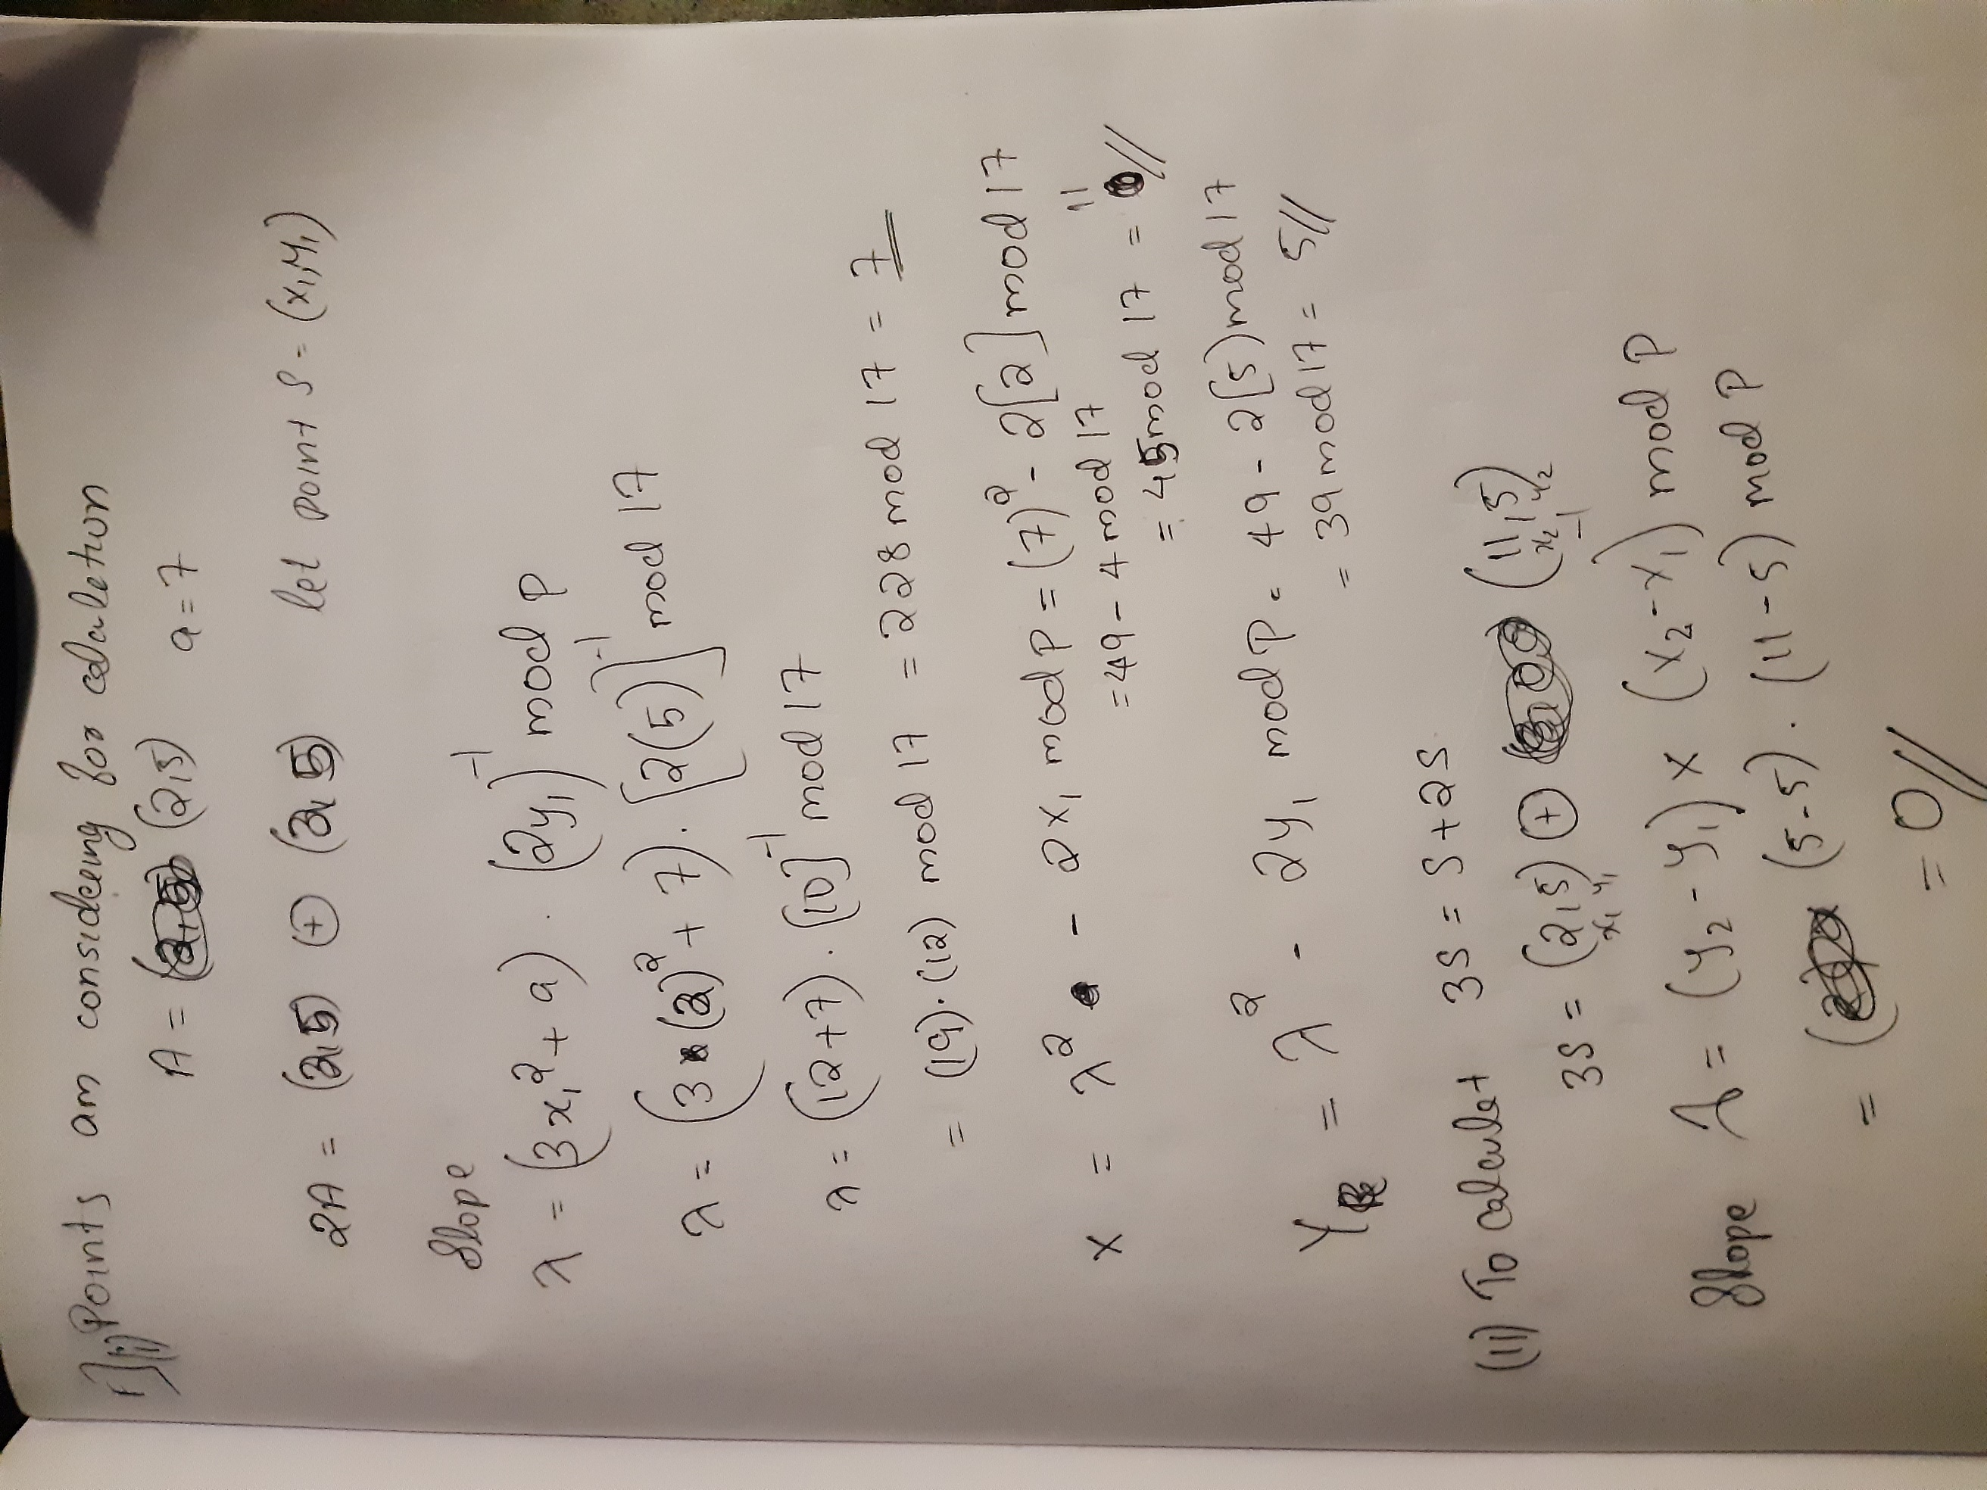

f)

